,

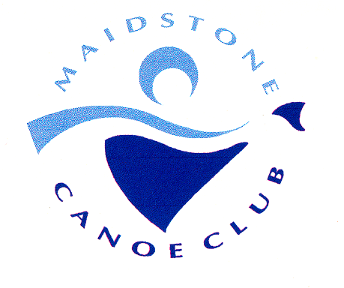
MAIDSTONE MARATHON 2022
( London and South East Region Hasler Event)

On Sunday 15th May 2022 Maidstone Canoe Club will be holding our Hasler Marathon Race and we would like you to join us. The race will be held in accordance with BC Marathon Racing rules.

VENUE:
Maidstone Canoe club,
Mill Meadow Wharf,
St Peter Street,
Maidstone
Kent
ME16 0SN
COURSES:
The races will be held on the river Medway which is a locked river on a recognised Canoe Trail. All courses are an out and back race
Div. 1 2 & 3 K1 & 2 3 K2 19 km 1 turn 4 Portages
Div. 4 5 & 6 K1 & 4 5 & 6 K2 15 km 1 turn 2 Portages
Div. 7 8 9 & 10 K1 & 7 8 & 9 K2 8km 1 turn 0 Portages
Geoff Sanders 4km 1 turn 0 Portages
PARKING:
There is limited parking at the club where you will be directed by stewards. It is possible to drop of boats but cars will be directed away by stewards so kindly follow their instructions. Parking is available on roads located nearby but we also hope to obtain extra parking within the location.
START TIMES:
Check in from: 9:30 am and closes at 11:00am
Briefing 11:30am Start 12:00am
ENTRIES:
Open 1st April 2022 and closes on Friday 13th May 2022
Senior £12
Junior £10
Geoff Sanders £5
All competitors will need to be a member of British Canoeing
£2 additional fee for payment on the day
Make entries using the Marathon race entry system Race Entries (gbcanoemarathon.co.uk)
But do not pay online
Payment transfers to Maidstone Canoe Club 60-60-08 48016721 quoting by preference the club/Hasler and number of entries as the reference e.g. WEY/HASLER 10
SAFETY:
All paddlers in Divisions 7 to 9 and U14s must wear approved buoyancy aids. Team leaders to decide
if paddlers in higher divisions should wear them.

RULES:
The race will be run in accordance with the current Marathon Racing rules

NUMBER BOARDS:
These will be issued at check in and will be collected after the race.
Lost boards are charged at £5

REFRESHMENTS:
Competitors food will be provided and other food and drink will be available for purchase.
PRIZES:
Medals to be presented around 3:30pm

QUERIES:
if you have any access requirements, or for any queries or changes to entries please contact Geoff Orford
and Catherine Ayling at marathon@maidstonecanoeclub.net

